🧪 Postman Setup Guide with Environment and Collection Files

✅ Prerequisites
- Make sure Postman is installed: Download from https://www.postman.com/downloads/
- You should have:
  - A .postman_collection.json file (e.g., my-api-collection.postman_collection.json)
  - An environment .json file (e.g., dev-environment.postman_environment.json)

📍 Step 1: Open Postman
- Launch Postman.
- You’ll see the Home screen with tabs like Workspaces, Collections, APIs, etc.
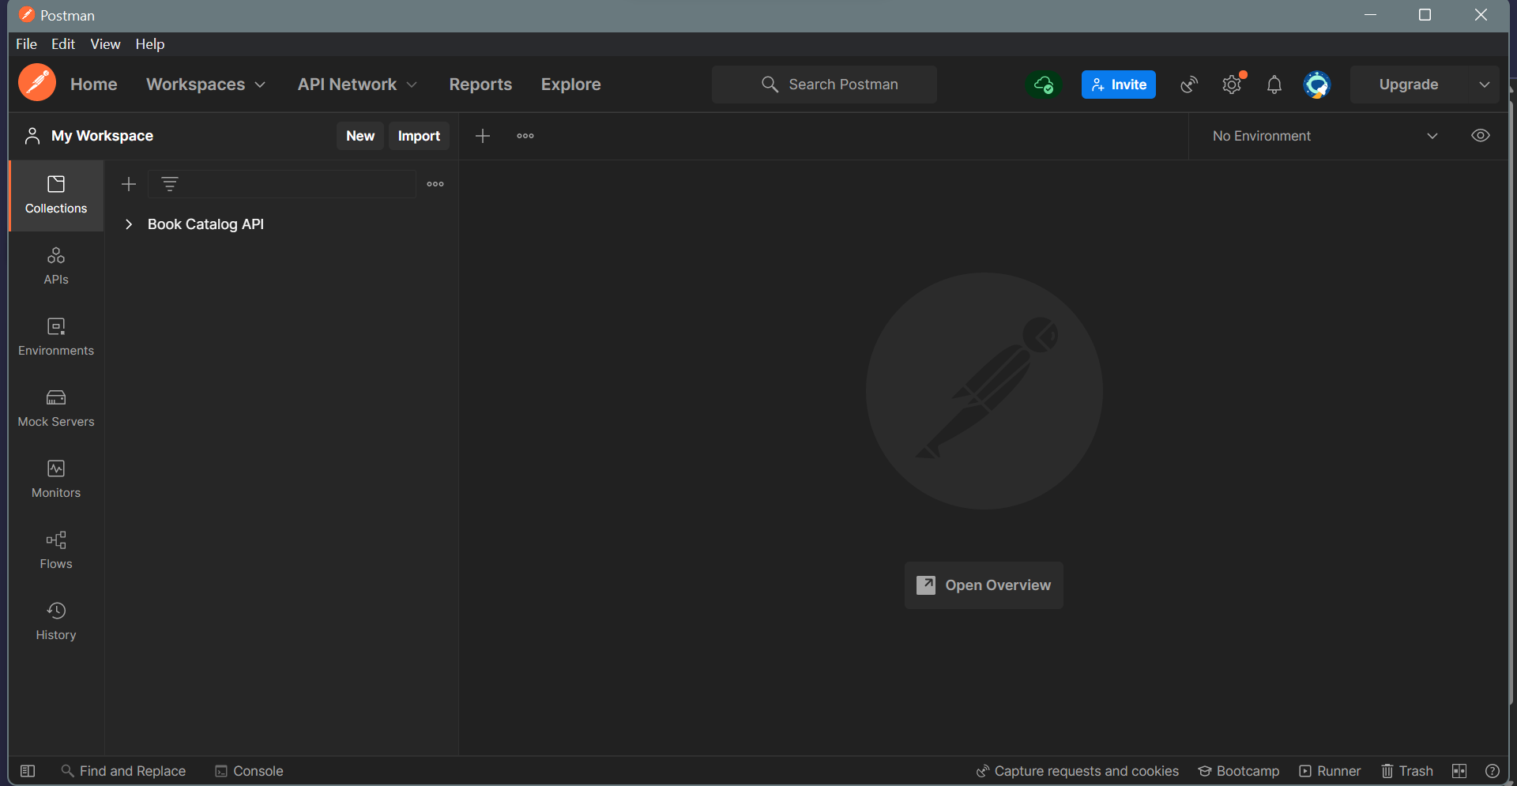

📂 Step 2: Import the Collection File
- Click the "Import" button (top left corner).
- Choose the File tab.
- Click "Upload Files" and select your .postman_collection.json file.
- Click "Import".
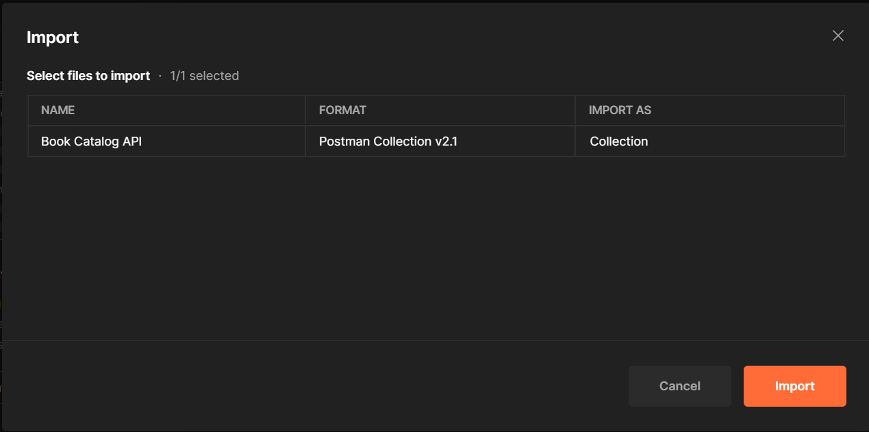

⏱️ After import:
- Your collection will appear in the Collections tab on the left panel.
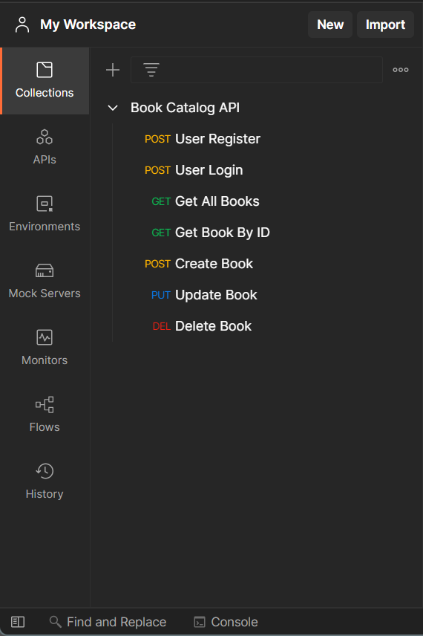

🌍 Step 3: Import the Environment File
- In the top-right corner, click the eye icon 👁️ (Environment quick look).
- Click "Import" in the pop-up that opens.
- Upload your .postman_environment.json file.
- Click "Import".
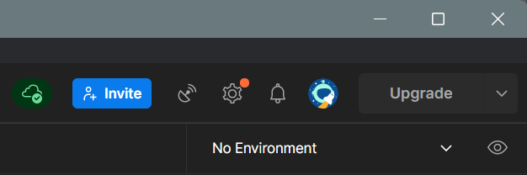
⏱️ After import:
- Your environment will be listed under Environments.
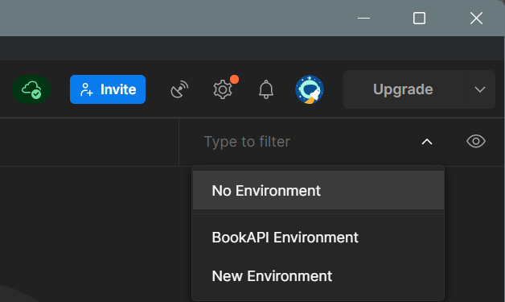

🔄 Step 4: Select the Environment
- Click the Environment dropdown in the top-right corner.
- Choose the imported environment (e.g., Dev Environment).

🚀 Step 5: Run a Request
- Expand the collection on the left.
- Click any request inside it.
- Click "Send" to test.

🧠 Extra Tips
- You can edit environment variables by clicking the eye icon > Edit.
- Collections and environments can be exported again via the three-dot menu next to their names.

✅ You’re Done!
You’ve now successfully set up Postman with your collection and environment. You’re ready to start making API requests.

